Combat robotics game

Theme: simple to pick up game to stimulate preparing a robot for a competition and fighting it

Vibe: things don't quite work how you want, chaotic, scrambling for fixes and dramatic hits
“You dont know what's going to happen when you enter the box”

Games emphasis is more on the making the bot than the driving it

Full rules writeup:

Robot Battles

A game about combat robotics.
Build a robot within your budget and weight limit, then defeat your opponents in a tournament of destruction.

Card anatomy:

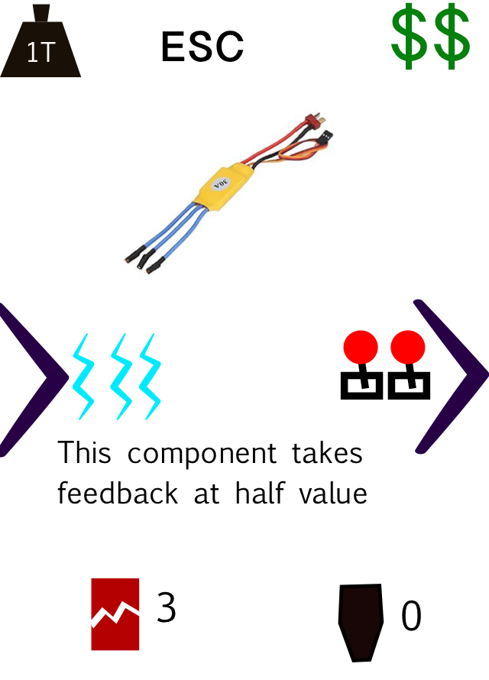

Price - you cannot have more total price in your pool than your budget
Weight - your robots total weight must be less than the weight limit

Requirements - a component is only active if its requirements are supplied by connected components. (Power, control, spin, pressure are the resources that need supply)

Durability: how much damage a component can take

Absorption: how much damage a component stops from being passed on during an attack

Outputs: what resources the component supply. Also includes drive

Ability text: any special rules for the component

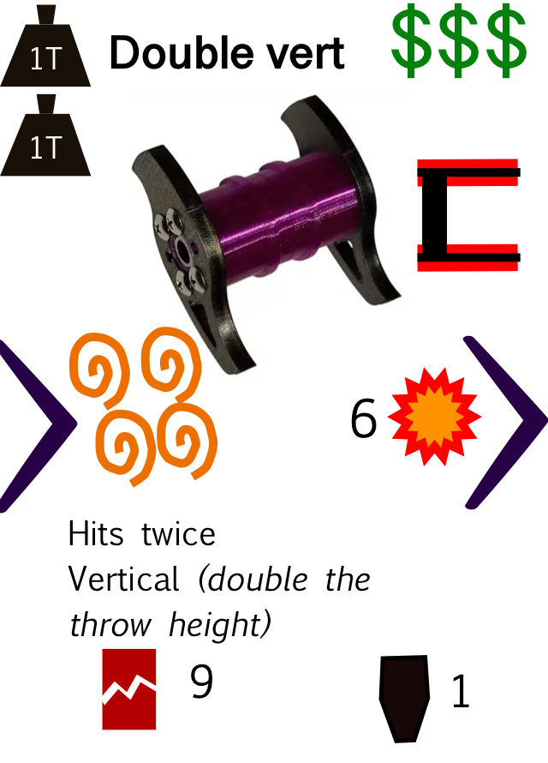
Weapon cards will have damage in their output zone, and a template marker indicating which template the component uses and where it attacks.

Robot construction:

Each robot is built onto a chassis. A chassis is a large mat that shows the robots shape and has a weight, cost and flip strength
. It may have an ability. All cards on the robot must be on the chassis.

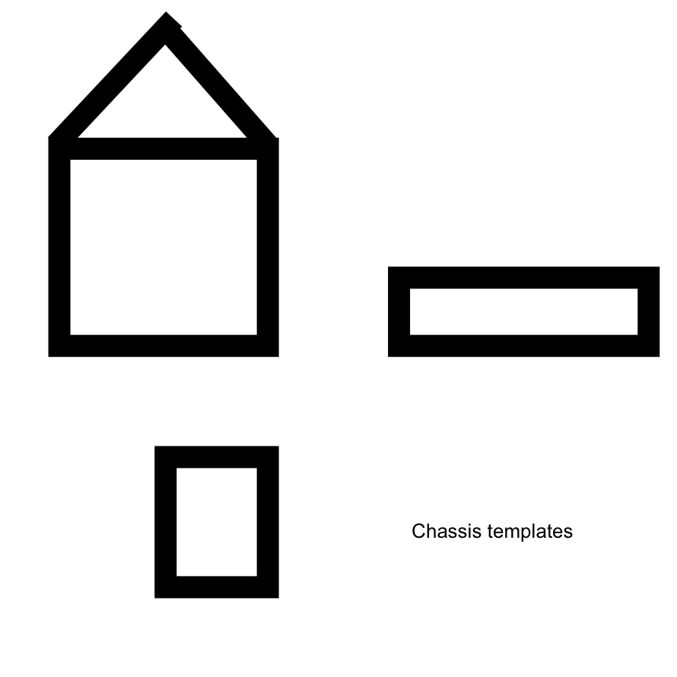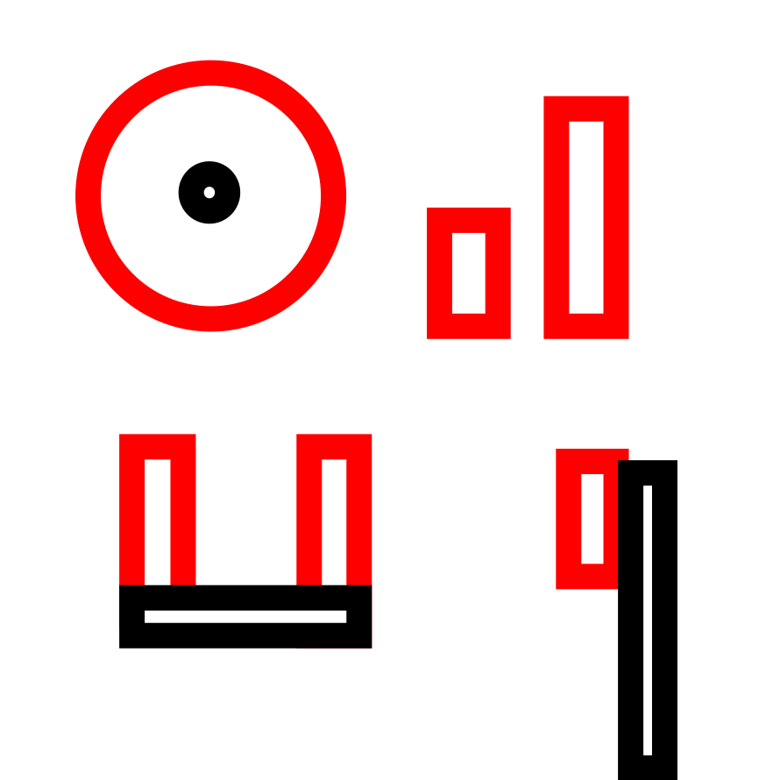

The chassis determines the model used for play.

A card is considered connected to any other card it is touching.

You may submit up to two robots, and the total weight across all the robots must be within the weight budget.

Each robot must have active drive to be submitted.

The Arena:

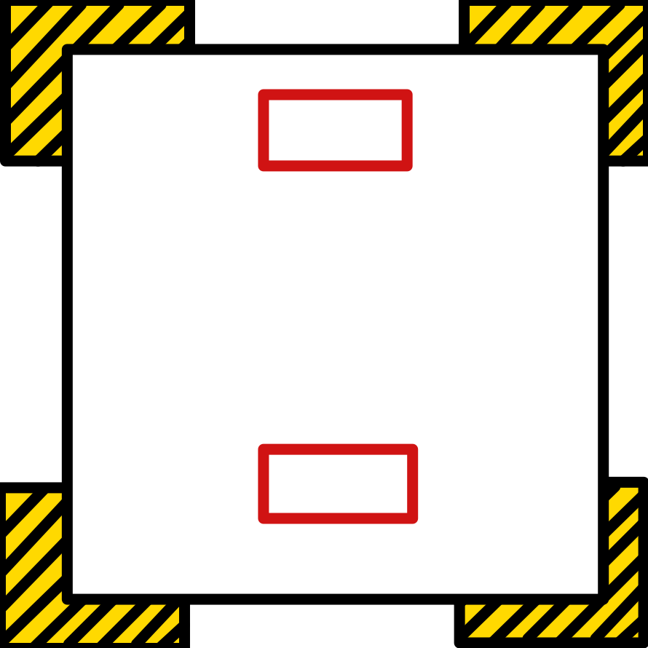

Red is starting area.
Black is walls
Yellow hatched is areas where if a robot is thrown there they exit the arena.

Battle:
Each battle starts with both players placing their robot marker (chassis plus weapon - made from fridge magnets or fancy 3d printed ones) to indicate the position of their robot in the starting zone of the arena.

The battle is played for 10 rounds or until a robot is unable to move - they have no active drive, or all their drive does not work due to inversion and they cannot unflip.

Each round follows the following structure:
- Planning
- Movement
- Collision
- Cleanup

Movement units are found on the straight movement template. Where an effect says a robot moves that amount, move them along that template without changing facing.

In the planning step each player chooses for each side a number with absolute value less than or equal to their active drive count for that side. 0/0 means no movement.

Then the choices are revealed and both robots are moved along the template corresponding to their chosen number pair.
The robot starts with its front at the black line on the template and ends with its front in line with the corresponding line.
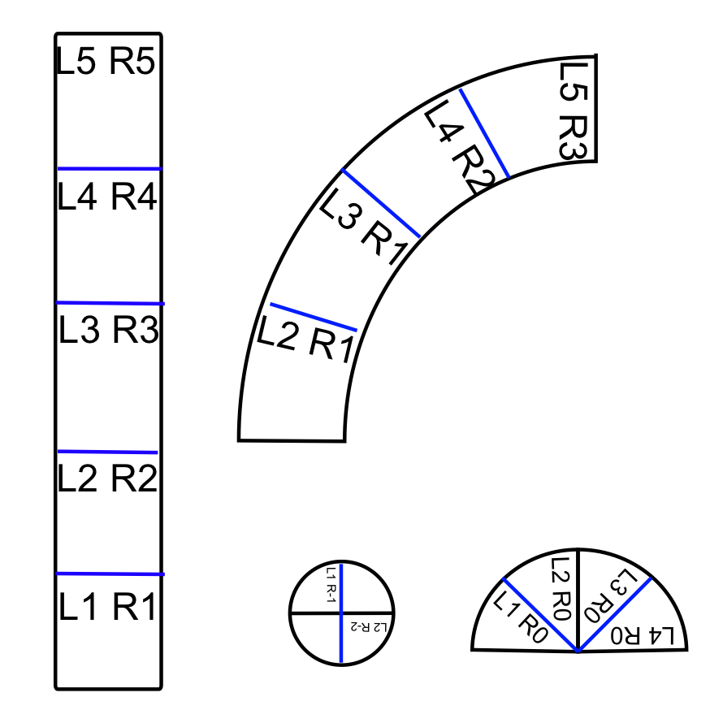

If the paths overlap then there is a collision at that point, and there is a collision if the robot would end up placed inside or in contact with something else.

Collision:
For a collision, first determine which octant of each robot makes contact with the other: place both robots as far along their path as they can go without touching the others path, then slowly move both forwards until they touch each other. Where the robots touch shows the contact point. Where ambiguous both components make contact

If the parts of either robot that is touching is the weapons active area (the red zone on the template) then the contact is active else its inert contact.

Inert contact:
Essentially a pushing match, the pair of robots move in the line drawn between their two centers through the point of contact. The distance they move is the sum of their remaining motion in that direction: all other distance is lost.
[Needs a diagram here]

If a robot is pushed into a wall it is thrown with a throw strength equal to the amount it would have moved if the wall wasn't there.

Each robot takes feedback shared equally between its remaining active drive equal to the remaining distance the opponent had before the contact.

Active contact:

All Weapons involved in the contact are assumed to hit, and they deal damage according to their damage level to the other robot to the components contacted.

Then both robots are thrown away from the contact. The base throw strength is equal to the attack strength received.

Weapons recieve feedback equal to half the attack strength.

Throws:
A robot that is thrown is moved a random amount up to the throw strength away in a random direction. If the throw strength minus the thrown distance is greater than the flip value of the chassis the robot is inverted.

Damage:
Damage progresses from the outermost component inwards, applying absorption at each step until all the damage is absorbed.
A component is destroyed if the remaining damage level that hits it exceeds its durability. A component is damaged if the remaining damage level minus that components absorption is greater than half its durability. If a damaged component would be damaged again it is instead destroyed. If a component is destroyed, it absorbs damage equal to its durability instead of its absorption.

Feedback:
Feedback represents components over-straining themselves under the combat loads. It is a damage that progresses back from the source component to each component that supplies it, shared equally if there are multiple components, down the tree until the damage is all absorbed.

Inverted:
While a robot is inverted weapons and drive without the invertible keyword dont work. If an inverted robot would be inverted again it becomes the right way up.

Raised:
Some components (mostly forks) will make the opponent raised if they make contact. A robot that's raises has it's drive strength halved for as long as its in contact with the component that raised it, and its flip strength is two lower.

Formats:
Preconstructed:
Each player brings a build deck up to the budget chosen (we recommend 25)

Then you each build a robot from that up to the weight limit and fight with those

Limited (recommended) :
There's a pool in the middle of cards, split into basic and special. You can grab anything from the basic pile, for special cards there is a market of 9 face up cards you can take from after which you must reveal the next card. You cannot return any card you have taken to the supply once you've taken it.
You cannot take more total cost than your budget ($25 recommended)
From this pool you build your robot to fight with. You are considered to have an infinite supply of all free components.

Quickstart/latecomer:
If you just want to dive right into the action you can grab one of the automaton robot sheets and play using that (in this case ignore the automation lines).

Tournament:
Robot Battles is designed to be played across multiple battles (typically 3), where you repair your robot from the spares in your supply between rounds. Components damaged in one round cannot be used in future rounds.

The winner of the tournament is the player with the most wins after all games are played.

Battles are played with random pairings for round 1, then with a winners play winners pattern. If you have an odd number of players, include an automaton as one person in the tournament. (Feel free to include more if you like)

Automaton:
There are some automaton robots which come with a pre-built setup printed on their A3 sheet. You can use dry-erase markers to write on this damage during a fight. They will take actions according to the table written on the right hand side of their sheet – each turn roll a d6 and look up the value from that table. They will always try to turn to face their opponent when turning.

